# Lean Code Contest – Implementation Guide

The whole lean code has been built with set of best practices and core components of the Adobe Experience Manager that will guarantee to make the Experience Manager implementations and migrations faster and more seamless. We have not written any custom code for implementing the lean code contest. There is no custom html, sightly and dialog created. The whole code has been followed with Adobe recommended code quality best practices with complete headless approach.

1. **AEM Version, Core component version and archetype Details:**

AEM Version: AEM6.5 with 6.5.6.0 service pack.

Archtype Version: 23

Core Component Version: core.wcm.components.all-2.11.1.zip

Login to AEM and got to http://yourhost/system/console/configMgr

Open Day CQ Link Checker Transformer and Tick "Disable Checking" Checkbox

**Lean code project structure:**

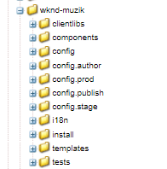

1. **Lists of used core components used:**

|  |
| --- |
| Accordion |
| Breadcrumb |
| Button |
| Carousel |
| Container |
| Embed |
| Experience Fragment |
| Form Button |
| Form Container |
| Form Options |
| Form Text |
| Image |
| Language Navigation |
| Layout Container |
| Navigation |
| Search |
| Separator |
| Tabs |
| Teaser |
| Title |

1. **CSS design:** The entire site implementation uses core components and we have written css and created Style to provide the look and feel of website pages. Here is a directory structure of CSS:

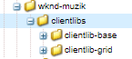

1. **Mail configuration:** HCL has used the out of box email configuration for sending an email for Membership sign up page . Here is configuration screenshots for configuring the SMTP details :

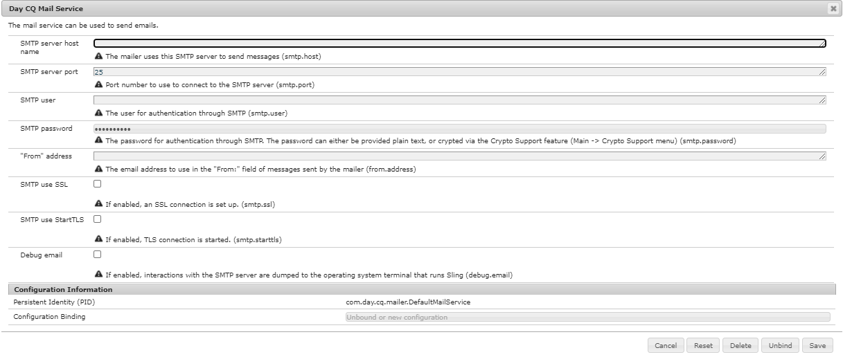

1. **Name of editable template for creating the page:** Content Page.
2. **Root Content Path:** /content/wknd-muzik/language-masters.
3. **List of components** that has been used for page creation.

|  |  |  |  |  |
| --- | --- | --- | --- | --- |
| **Components List** | | |  |  |
| **S.No.** | **Page** | **Section** | **Core Component** | **Style System** |
| 1 | **Home Page** | Slide Show | Carousel |  |
|  |  | Teaser | Teaser Text Overlay - Text Align Left - Text Align Right - Text Align Center |
|  |  | Image and Text | Container | Vertically Center Grid |
|  |  | Image |  |
|  |  | Text |  |
|  |  | Musician Types | Title |  |
|  |  | Teaser | Music Type |
|  |  | Button | Button Center |
|  |  |  |  |  |
| 2 | **Membership Page** | Breadcrumb & Banner | Breadcrumb |  |
|  |  | Teaser | Blue Banner |
|  |  | Plans | Title |  |
|  |  | Teaser | Membership Price |
|  |  |  |  |  |
|  |  | Show Popular/Upcoming | Title |  |
|  |  | Tabs |  |
|  |  | Teaser | Show List |
|  |  | Video | Title |  |
|  |  |  | Video Component | Embed |
|  |  |  |  |  |
| 3 | **Sign In Page** |  | Title | Center both title and underline |
|  |  |  | Form Container |  |
|  |  |  | Form Text |  |
|  |  |  | Form Options |  |
|  |  |  | Form Button |  |
|  |  |  | Breadcrumb |  |
|  | **Confirmation Page** |  | Title | Center both title and underline |
|  |  |  | Text |  |
|  |  |  | Teaser | Teaser Text Overlay |
|  |  |  | Breadcrumb |  |
|  | **FAQs** |  | Accordion |  |
|  |  |  | Text |  |
|  |  |  | Title |  |
|  |  |  | Breadcrumb |  |
| 4 | **Header** | Experience Fragment | Image |  |
|  |  |  | Navigation |  |
|  |  |  | Button |  |
|  |  |  | Language navigation |  |
|  |  |  | Search Box |  |
|  |  |  |  |  |
| 5 | **Footer** | Experience Fragment | Navigation |  |
|  |  |  | Button |  |
|  |  |  | Separator |  |
|  |  |  | Text |  |

1. **MSM Structure: HCL has created the** Multi Site Manager (MSM) that will allow author to create copy of existing site and automatically update the copy when changes are done to the source site.

Here is wknd-muzik MSM structure:

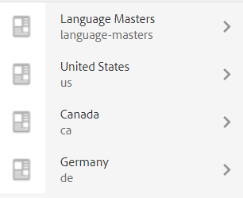

1. **GitHub link: https://github.com/munish-hcl-technologies/wknd-muzik**
2. **Git commands:**

* git clone https://github.com/munish-hcl-technologies/wknd-muzik.git
* git pull origin master

1. **Deployment steps for author and publish server**

If you have a running AEM instance you can build and package the whole project and deploy into AEM with following command

* mvn clean install -PautoInstallPackage

Or to deploy it to a publish instance, run with following command

* mvn clean install -PautoInstallPackagePublish